# Investment Analytics

# FDI in INDIA

# Wireframe Documentation

Written by :- AMIT KUMAR

As per the problem statement, I have divided analysis into three sections:

1. Top and Bottom sectors in last 5 years with trends in sector from year 2000-16.

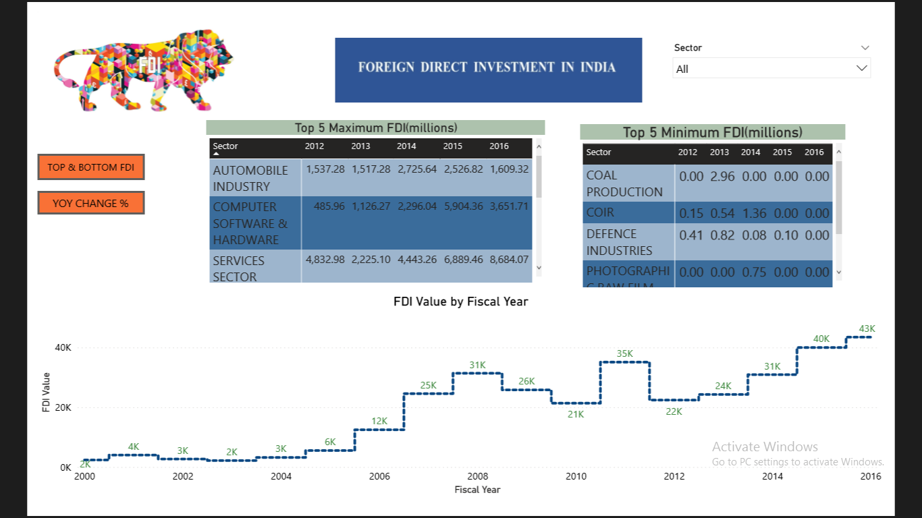

In this section I designed the dashboard and tried to interpret the followings :

* Top 5 sectors in last 5 fiscal years

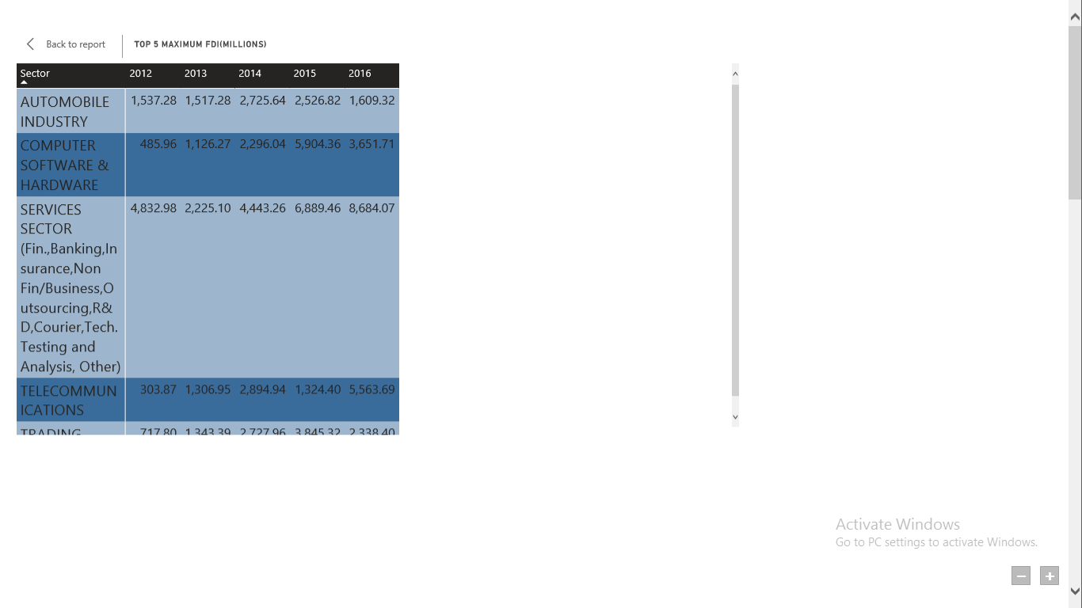

* * Top 5 bottom sectors with lowest FDI value

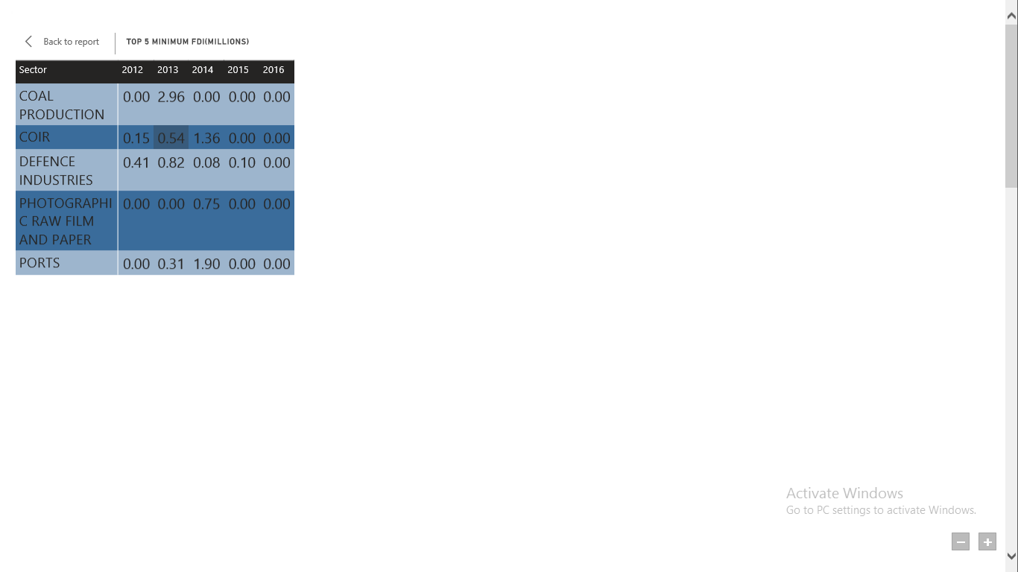

* Trend of sectors in different fiscal years.

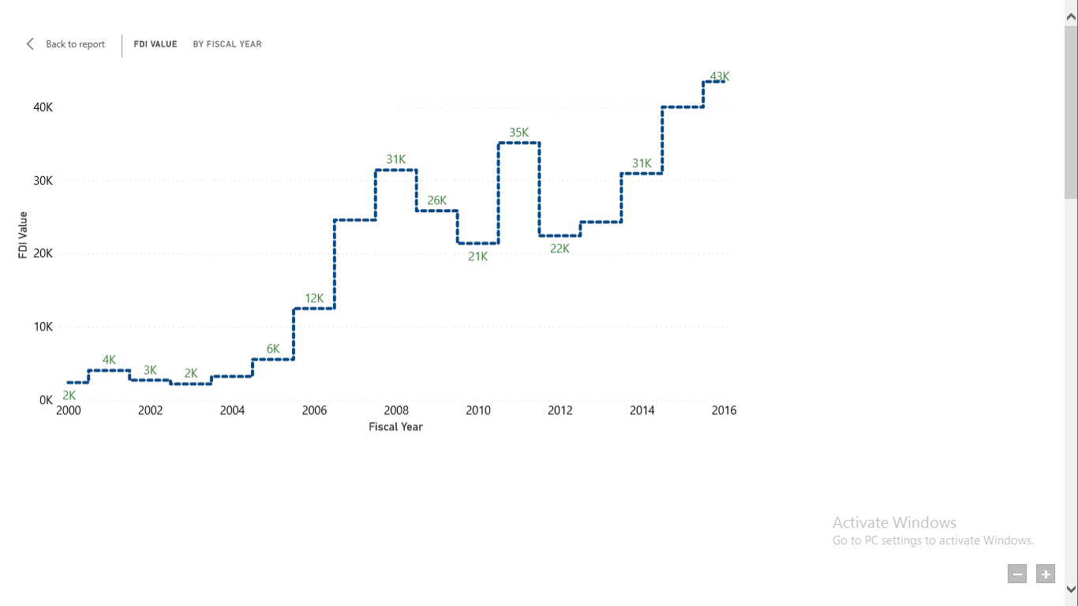

* Top 5 sectors with year over year change in investment.

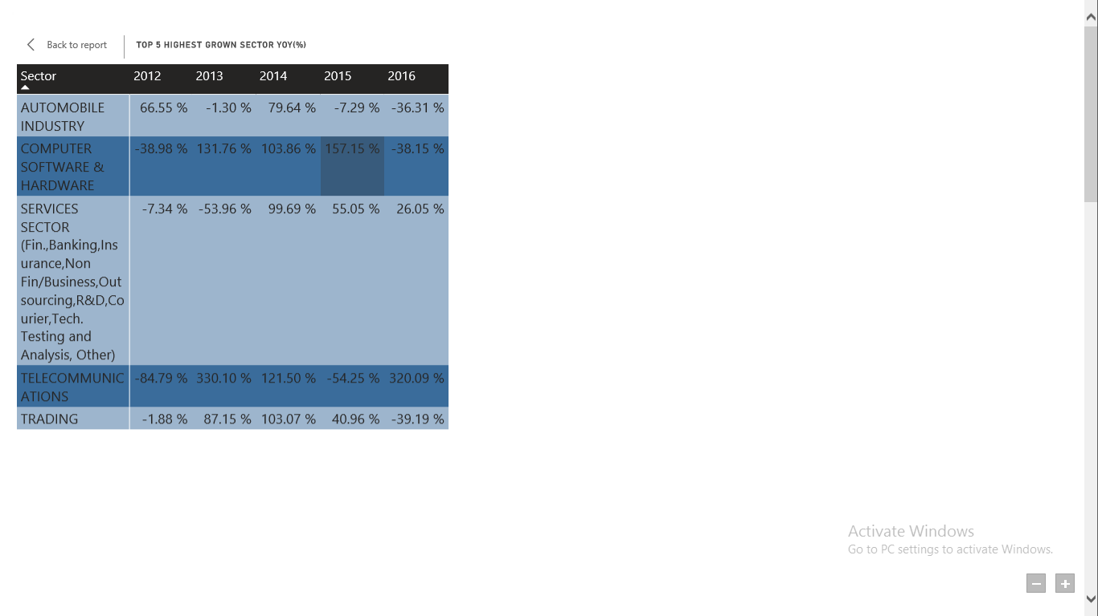

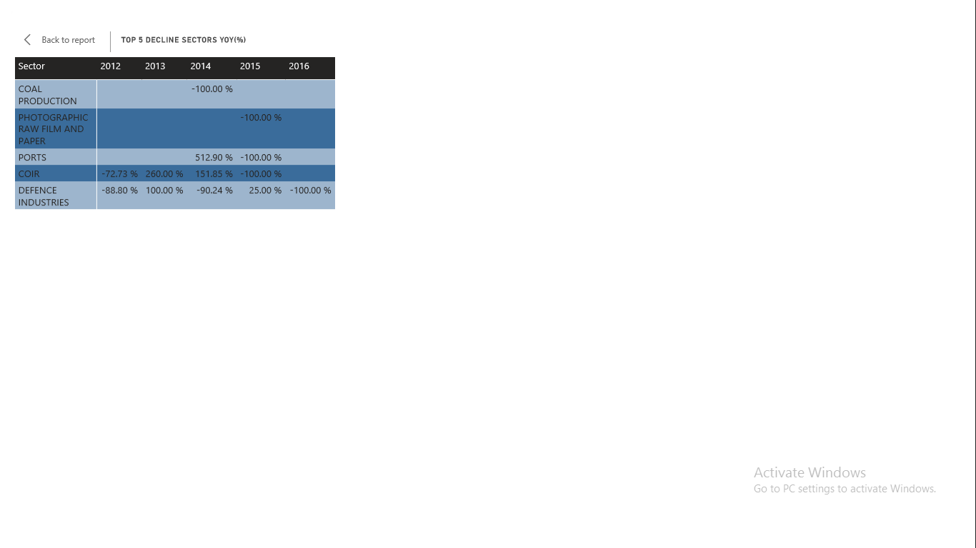  
* Bottom 5 sectors with year over year fdi investment.

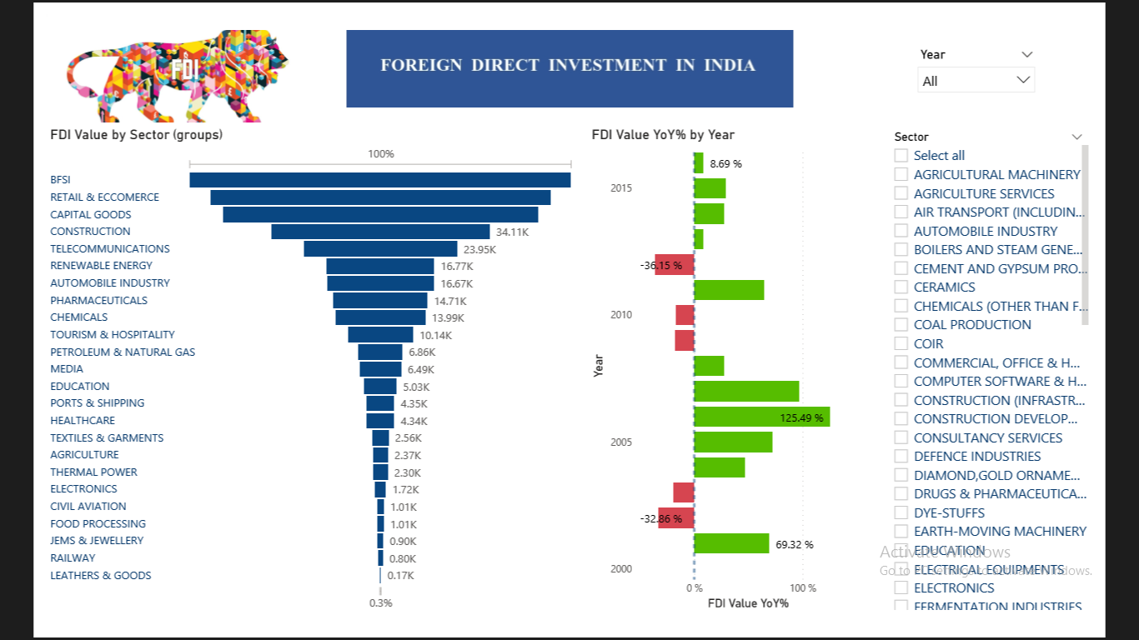  
2. Variation in sector with FDI investment year over year .

* Variation in sectors with different groups and FDI investment.

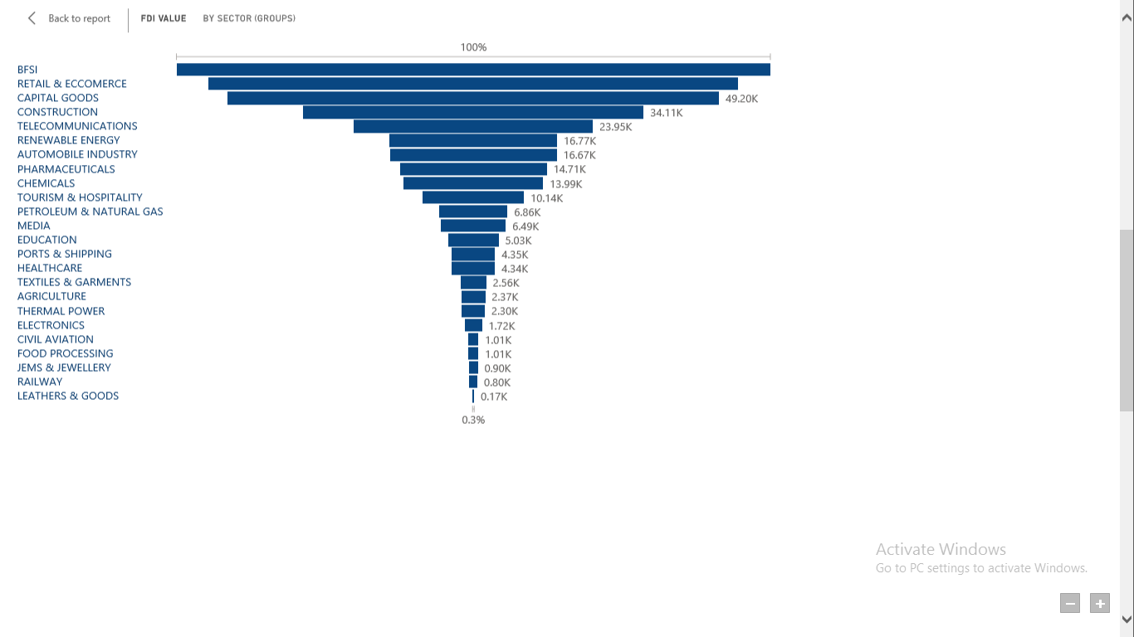

* Sector wise change in fdi value in every fiscal year.

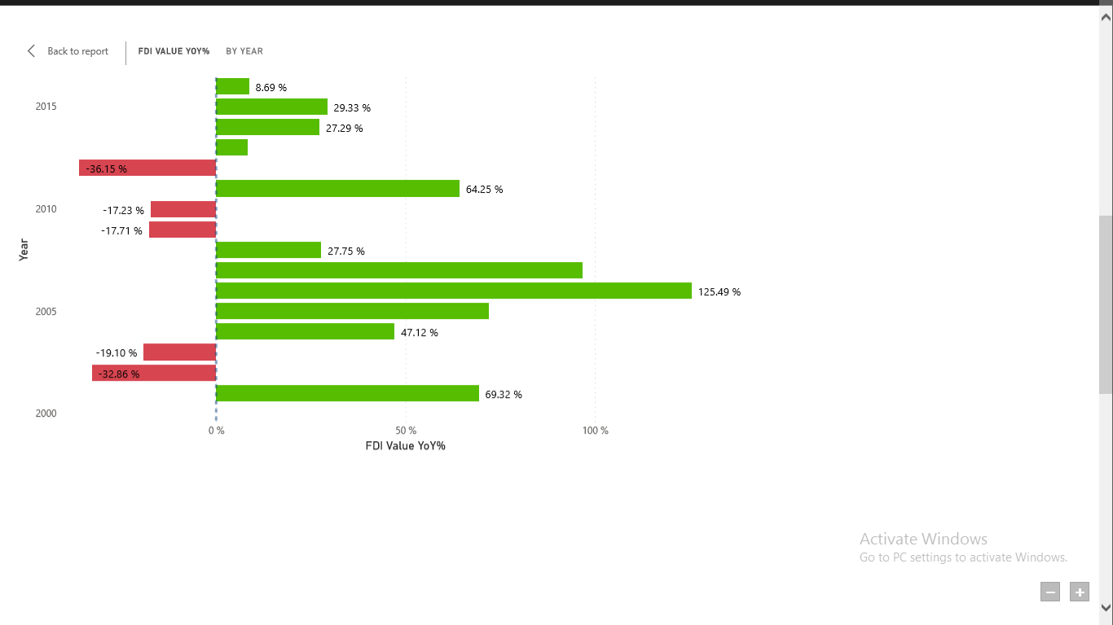

* Future forcast and clusters shown wrt sectors for different fiscal year.

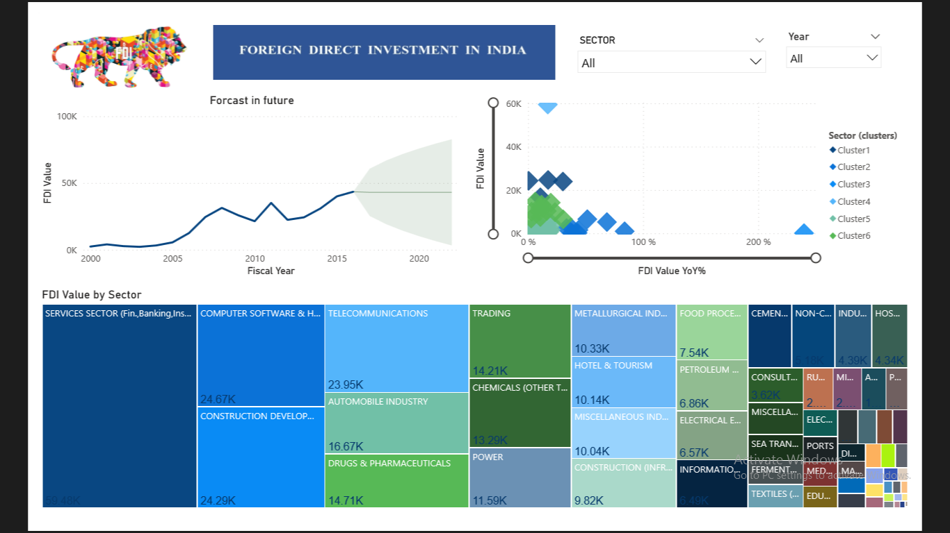

* Future forcast trend of different sectors for upcoming 6 years.

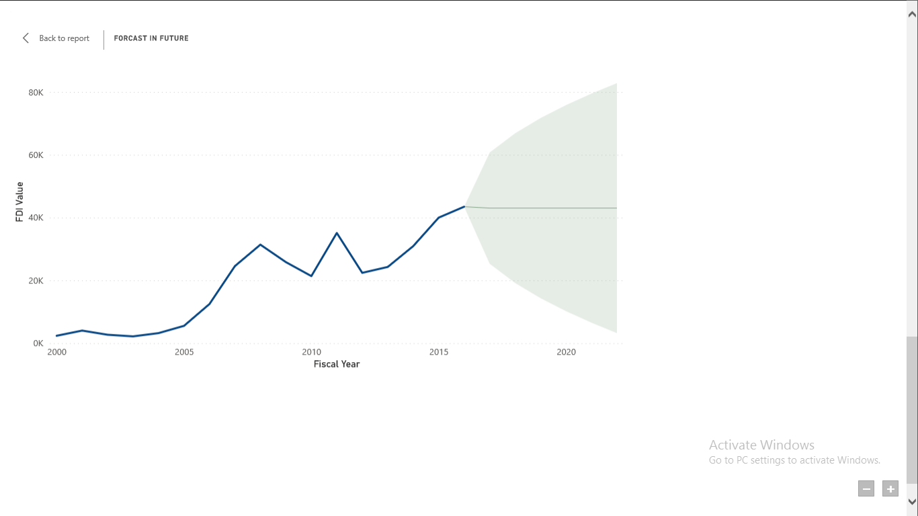

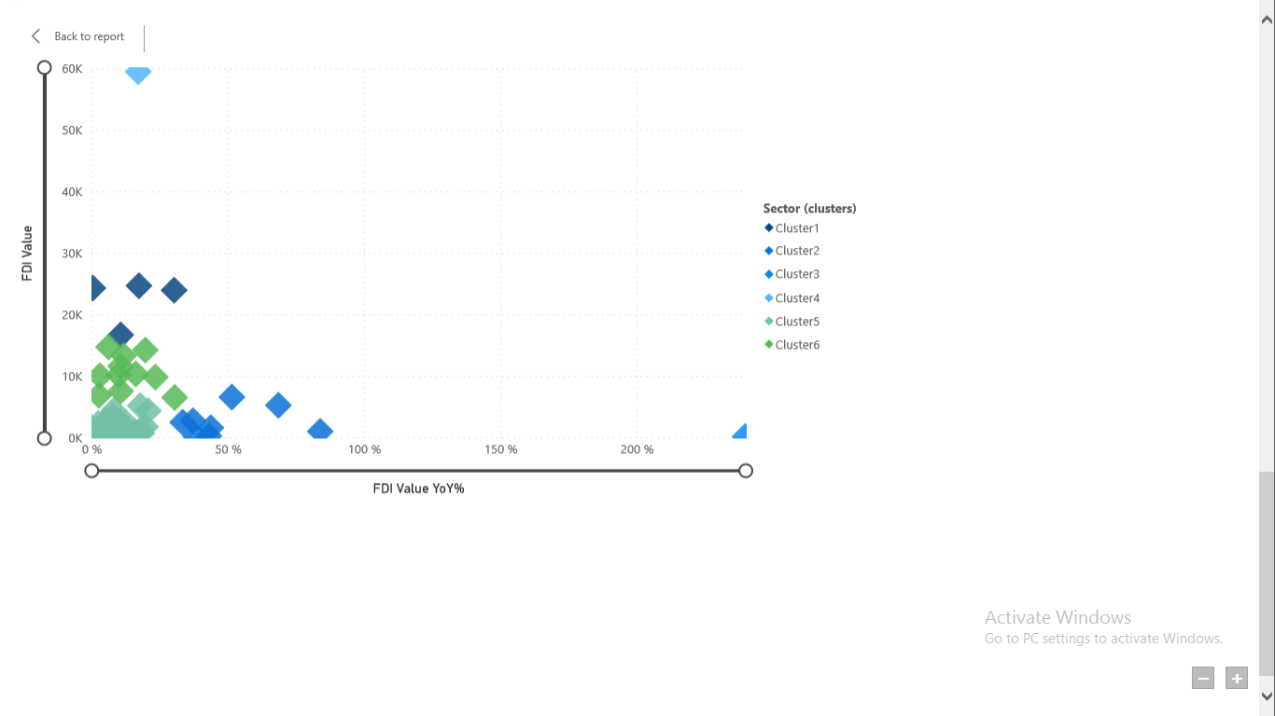

* Cluster found for different sectors.

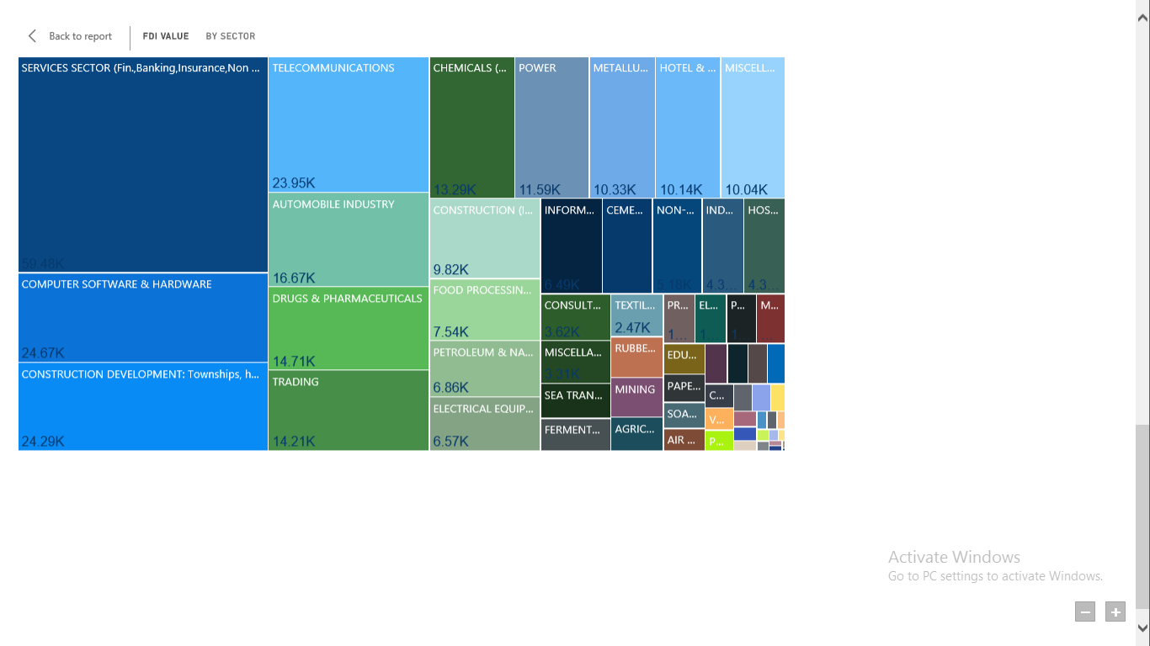

* Proportion of investment between sectors from the FDI perspective.